NC Lab 2
11762 Muhammad Kashif
Task 1
Code tolarance 0.001
x = s.Symbol('x')
def f(x):
return m.cos(x)-1.3*(x)
def bisection(x,y):
prev = 0
app = 0
for i in range(15):
a = (x+y)/2
app = prev - a
prev = a
if (f(a)<0):
x = a
else:
y = a
root =y-x
print(i+1,".iteration", a,"Tolarance", app)
if root< 0.002 and root >= 0.001:
break
bisection(0,1)
Output
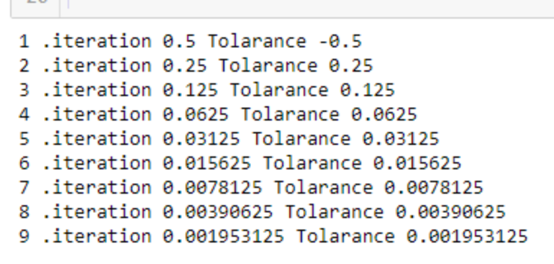
Task 2
Code tolarance 0.001
x = s.Symbol('x')
def f(x):
return (x+1)**2-2*x*m.cos(2*x)
def bisection(x,y):
prev = 0
app = 0
for i in range(15):
a = (x+y)/2
app = prev - a
prev = a
if (f(a)<0):
x = a
else:
y = a
root =y-x
print(i+1,".iteration", a,"Tolarance", app)
if root< 0.002 and root >= 0.001:
break
bisection(0,1)
Output
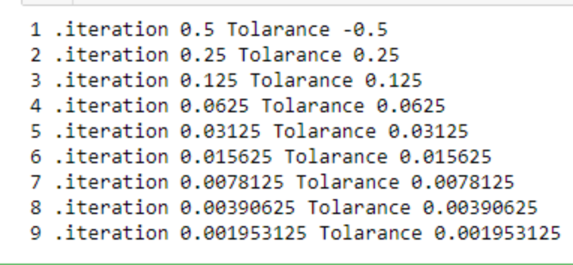
Task 3
Code tolarance 0.01
x = s.Symbol('x')
def f(x):
return m.cos(x)-1.3*(x)
def bisection(x,y):
prev = 0
app = 0
for i in range(15):
a = (x+y)/2
app = prev - a
prev = a
if (f(a)<0):
x = a
else:
y = a
root =y-x
print(i+1,".iteration", a,"Tolarance", app)
if root< 0.02 and root >= 0.01:
break
bisection(0,1)
Output
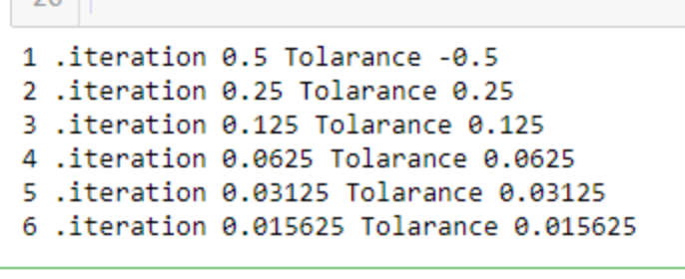
Task 4
Code tolarance 0.01
x = s.Symbol('x')
def f(x):
return (x+1)**2-2*x*m.cos(2*x)
def bisection(x,y):
prev = 0
app = 0
for i in range(15):
a = (x+y)/2
app = prev - a
prev = a
if (f(a)<0):
x = a
else:
y = a
root =y-x
print(i+1,".iteration", a,"Tolarance", app)
if root< 0.02 and root >= 0.01:
break
bisection(0,1)
Output
